Jim Sinegal
1936-
Wikipedia:
James D. Sinegal is co-founder and CEO of Costco, an international low-price membership retail chain and the largest U.S. wholesale club. . . . . He was a protege of Sol
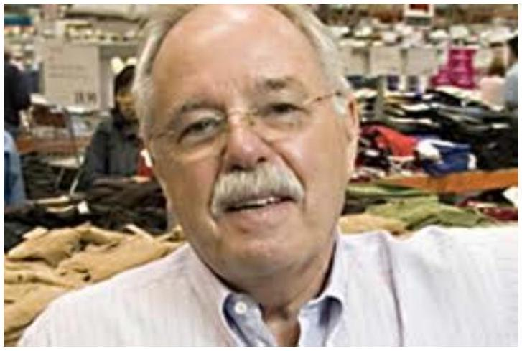
Price, who pioneered the concept of the warehouse store that sells high volumes of a small variety of goods to members only. Sinegal is known for a benevolent style of management that offers employees high benefits and rewards.
New York Times (by Stephen Greenhouse):
With his ferocious attention to detail and price, Mr. Sinegal has made Costco the nation's leading warehouse retailer, with about half of the market, compared with 40 percent for the No. 2, Sam's Club. But it is the customer, more than the competition, that keeps Mr. Sinegal's attention. "We're very good merchants, and we offer value," he said. "The traditional retailer will say: 'I'm selling this for $\$10$. I wonder whether I can get $\$10.50$ or $\$11$.' We say: 'We're selling it for $\$9$. How do we get it down to $\$8$ ?' We understand that our members don't come and shop with us because of the fancy window displays or the Santa Claus or the piano player. They come and shop with us because we offer great values." . . . . .
One reason the company has risen to the top and stayed there is that Mr. Sinegal relentlessly refines his model of the warehouse store - the bare-bones, cement-floor retailing space where shoppers pay a membership fee to choose from a limited number of products in large quantities at deep discounts. Costco has 44.6 million members, with households paying $\$45$ a year and small businesses paying $\$100$.
A typical Costco store stocks 4,000 types of items, including perhaps just four toothpaste brands, while a Wal-Mart typically stocks more than 100,000 types of items and may carry 60 sizes and brands of toothpastes. Narrowing the number of options increases the sales volume of each, allowing Costco to squeeze deeper and deeper bulk discounts from suppliers. . . .
If Mr. Sinegal feels proprietary about warehouse stores, it is for good reason. He was present at the birth of the concept, in 1954. He was 18, a student at San Diego Community College, when a friend asked him to help unload mattresses for a month-old discount store called Fed-Mart.
What he thought would be a one-day job became a career. He rose to executive vice president for merchandising and became a protégé of Fed-Mart's chairman, Sol Price, who is credited with inventing the idea of high-volume warehouse stores that sell a limited number of products.
Mr. Price sold Fed-Mart to a German retailer in 1975 and was fired soon after. Mr. Sinegal then left and helped Mr. Price start a new warehouse company, Price Club. Its huge success led others to enter the business: Wal-Mart
started Sam's Club, Zayre's started BJ's Wholesale Club and a Seattle entrepreneur tapped Mr. Sinegal to help him found Costco.
Richard Rumelt:
Jim Sinegal has hued to a basic formula he learned from Sol Price and has refined every year. The formula is to
- Sell only a limited number of items, especially those which are great deals for the consumer
- Sell to members only
- Offer food and other items that draw upscale shoppers and small business owners
- Keep the physical set-up bare bones. Sell directly off pallets placed on cement floors.
- Don't advertise. That saves $2\%$ by itself.
- Be super-vigilant about prices.
- Take care of your employees but squeeze your suppliers without mercy.

